Management and Information System

PARADISE TOURS

Report

# Application Description:

The application software is a management and information system for a tour agency named Paradise Tours. The software is based on a three-tier design, that are Application/UI layer, Business Logic Layer, and Services Layer. The application handles the major business flow of the tour agency including the CRUD operations of tours, CRUD operations of clients, CRUD for reservations etc. The application uses several different patterns for a good design such as the GRASP patterns.

# Use Case Diagram:

# 

# Domain Model:

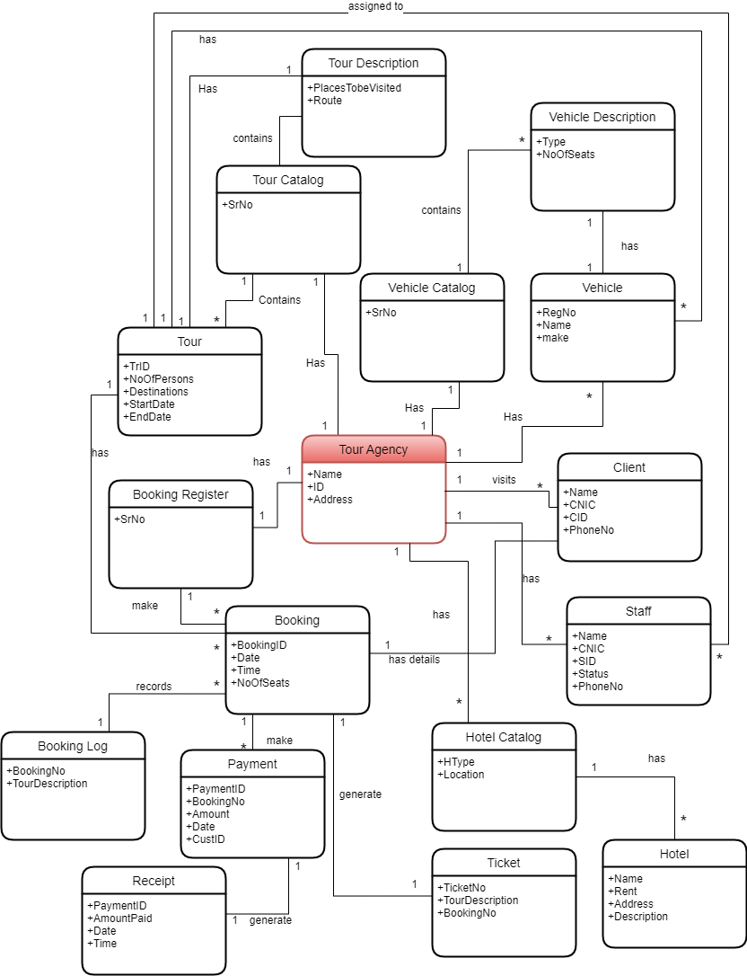

The above domain model depicts all the useful concepts in the specified domain, their interrelationships, and the cardinality between them. The domain model also shows some of the attributes of each concept.

# Use cases:

Use-cases of the system are written and attached within a separate file. These extended use-cases were gathered from user stories and other domain expert opinions and further used to develop the software.

# Separation of tiers:

The effort has been to separate the tiers as much as possible. There are no objects from the Business Layer that are being sent to or received from the UI. Similarly, no objects are being sent to the services layer like the storage or payment etc. This makes the software technology independent in a way that any change to the UI layer will require little to no change in the business logic and the services layer. Suppose that the UI has been changed to voice input, the same function parameters are being sent to the functions provided by the Business Layer. Similarly, a change in the services layer, let’s say change of storage technology, will not effect the UI at all, and little to no change in the business layer.

# Good Software Patterns:

The following GRASP (General Responsibility Assignment Software Patterns) are applied within the code, as long as their depiction:

## Creator:

The concept of creator addresses the problem of which class or object creates the other class or object. The LPG (low representation gap) has been kept in mind which designing the classes and their relations.

Following are some examples of the Creator Pattern:

Class *TourAgency* creates classes *TourCatalog, ReservationRegister, and ClientRecords* because it is composed of the latter classes.

Similarly, class *TourCatalog* creates *Tour* object since it contains" or compositely aggregates class *Tour,* and thus has the responsibility of creating it.

Similarly, class *ReservationRegister* aggregates *Reservation* objects and is the creator for it.

The class *ClientRecords* contains *Client* type objects so it is the creator for it.

Same pattern can be seen at other places in the code.

The names of the classes and their relations have been designed so that the Low Representation Gap is maintained and the relationships are rather intuitive and more understandable.

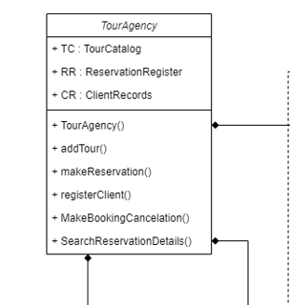

Figure A depiction of Creator Class

## Information Expert:

The question “Who knows about a Square object, given a key” is used in the code design. The Information Expert principle is used and objects like Tour are stored in the TourCatalog, which is naturally intuitive, and also supports other principles like low coupling and high cohesion. The *Knowing* responsibility is fulfilled by keeping ArrayList of *Client* objects in *ClientRecords* just like the *TourCatalog* example. The *doing* responsibility is also satisfied as the operations performed with the objects *Tour, Client, and Reservation* are handled by *TourCatalog, ClientRecords, and ReservationRegister* respectively.

## Low Coupling:

Low coupling principle can be observed in the code as well as in the class diagram. No class has been coupled with another class unless there is a strong relationship between the two. The *Information Expert* principle and the *Low Coupling* principle complement each other. By the virtue of using *Information Expert* pattern, there had already been Low Coupling but still the choices were coupling was relatively lower have been made. For instance, *Client* object has no relation coupling with *Tour*, but the job is done by the *Reservation* class since it has an association relationship with the *Tour* class. *Low Coupling* helps in making the code easier to maintain and write, as well as reduces the *Ripple Effect.*

## Controller:

The controller pattern guides us on the problem of which object (in the Business Logic Layer) first receives the call from the UI layer. There were two options, the first one of having an overall “system” controller, or adding use-case controller. The software in review uses the prior one, and contains just one controller, called the *TourAgency.* Thus, the *TourAgency* is the controller which is our overall system or the root object. The *TourAgency* controller acts as a façade for all system calls. So, all the calls from the UI layer will be received by the *TourAgency* class (against all the UI events), and the *TourAgency* class will forward the calls to the respective *Information Experts*. Therefore, there will be Lower Coupling between classes as well. However, the principle of *High Cohesion* is a little bit compromised, but since there are not too many calls, the choice of Root Controller over Use Case controller s a better choice.



Figure A Depiction Of Controller

## High Cohesion:

High Cohesion is kept in mind during the assignment of responsibilities to different objects. The two guiding principles that aid High Cohesion are the relatedness of the objects and the amount of code in a software element or a class object. Hence, the approach has been to minimize the number of functions/methods and minimizing the SLOC (Source Lines of Code). This has especially been followed for the Controller class so it has to do the coordination work and forwarding of calls from the UI rather than performing logic operations itself. This pattern has been followed throughout the classes and the *doing responsibility* is assigned to the most intuitive classes. The controller class delegates and coordinates the work for all the calls from the UI, and forwards them to the respective responsible classes. For instance, the *addTour()* call from the UI event is sent to the controller *TourAgency,* which is forwarded to *TourCatalog* which contains the *Tour* objects, and hence has the responsibility of adding a new *Tour*. Hence, *High Cohesion* has been supported in the code.

# Indirection:

## Polymorphism:

Since the type of storage can differ for different purposes, the concept of polymorphism is used and a PersistanceHandler class has the responsibility of storing objects from the Business Layer using the Services Layer. Hence, the PersistanceHandler class connects the BL to the Services Layer. Since the storage type can vary, the PersistanceHandler is created at runtime by the use of polymorphism, and one of the child types can be created and used to store the data in the specified data storage. For instance, we have the PersistanceHandler class which inherits the FileStorage, OracleDBStorage, and the MySQLStorage classes, of which one type of object is created at runtime. The configure.prop file is read and the specified type of storage object is created and used by every class which needs to store data.

The same concept applies to the paymentHandler method.

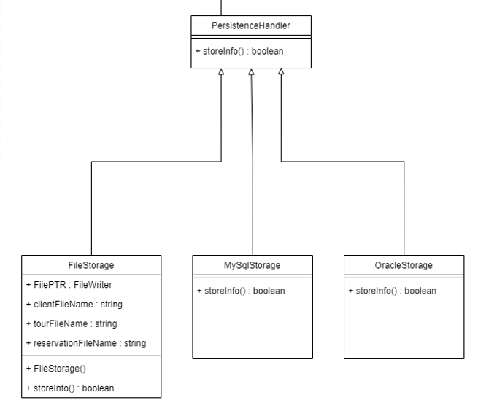

Figure Polymorphism

## Singleton Class:

Since only one object of the *persistanceFactory* class should exist, the constructor of this class is private, and the class contains the method getInstance() which returns the reference to the *persistanceFactory*, and initializes it for the very first time. The calls to the persistanceHandler can then be made by using the object from the persistanceFactory from anywhere in the code, since the method is *static*. The paymentFactory class also uses the same principle.

## Factory Class/Method:

Since the type of persistenceHandler is decided at runtime, the code contains a persitanceFactory which creates the persistanceHandler. The class itself is a singleton class, which is discussed in the next subheading. The persistanceFactory contains the static getInstance() method so every class that needs to store something in the storage can use it.

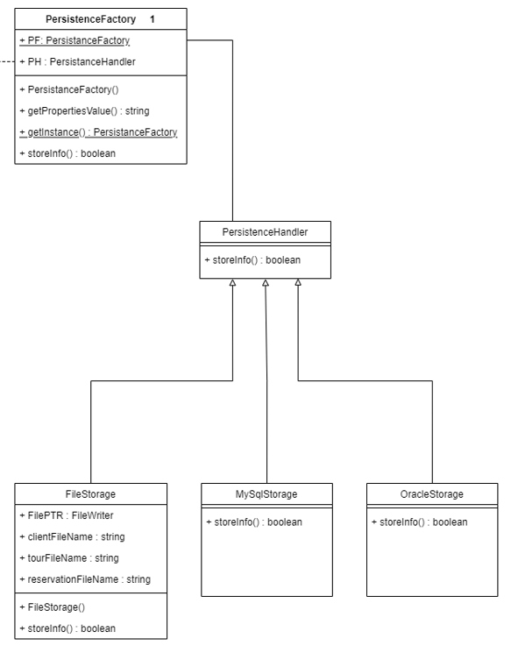

Figure Depiction of Factory Method and Singleton Class

## Adapter Pattern:

The *Adapter* pattern has been applied to the payment class so that the adapter objects act as intermediaries to the external payment providers. By the use of polymorphism, the subclasses of the payment handler provide a consistent interface to the inner objects and hide the variations in the external APIs. The *adapter* pattern helps reducing the ripple effect and increases code reusability since the same adapter can be used at many different places in the system. Any variation in the APIs provided by external service providers will not cause change in the Business Logic anywhere other than the payment adapters. For instance, any change in the APIs provided by the database or other storage services providers will be handled by the adapter. Adding a new service such as cloud storage will require some change in the persistenceFactory class only, and an addition of a child class of persistanceHandler. Similarly, the *paymentHandler inherits* three different adapter class named *payByCash, payByEasyPaida, payByCard.* Adding a new payment method would require adding just one more class to the hierarchy, and just one more LOC in the *paymentFactory* class. 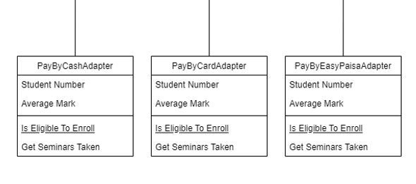

Figure Adapaters

# System Sequence Diagrams:

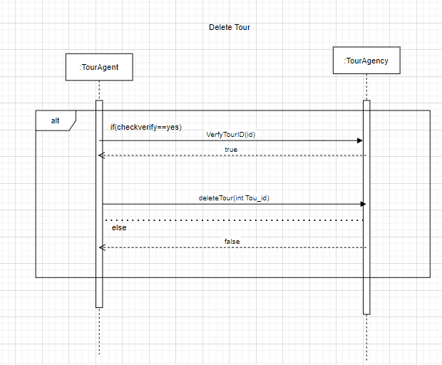

Figure Delete Tour SSD

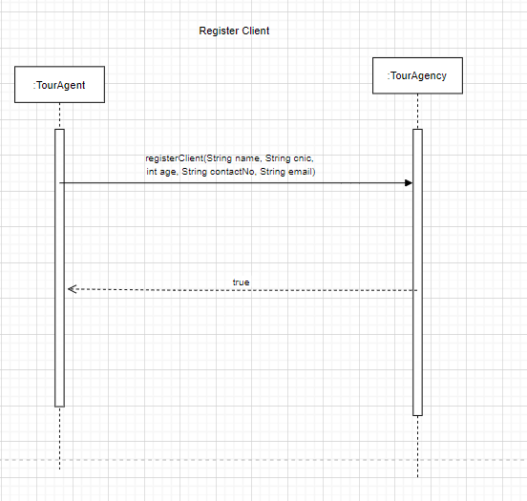

Figure Register Client System Sequence Diagram

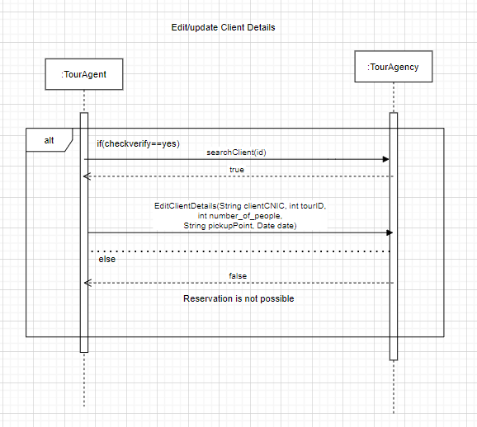

Figure Update Client Details System Sequence Diagram

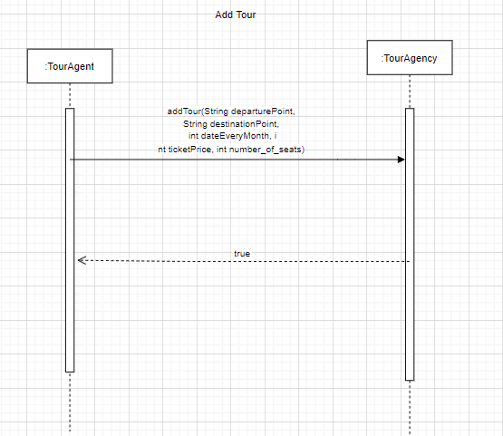

Figure Add Tour System Sequence Diagram

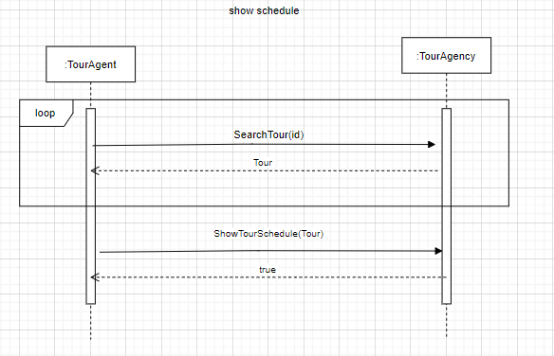

Figure show schedule System Sequence Diagram

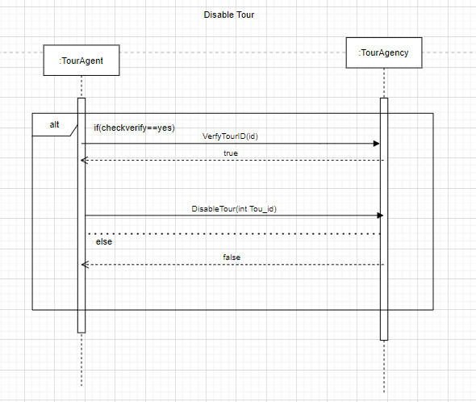

Figure Disable Tour System Sequence Diagram

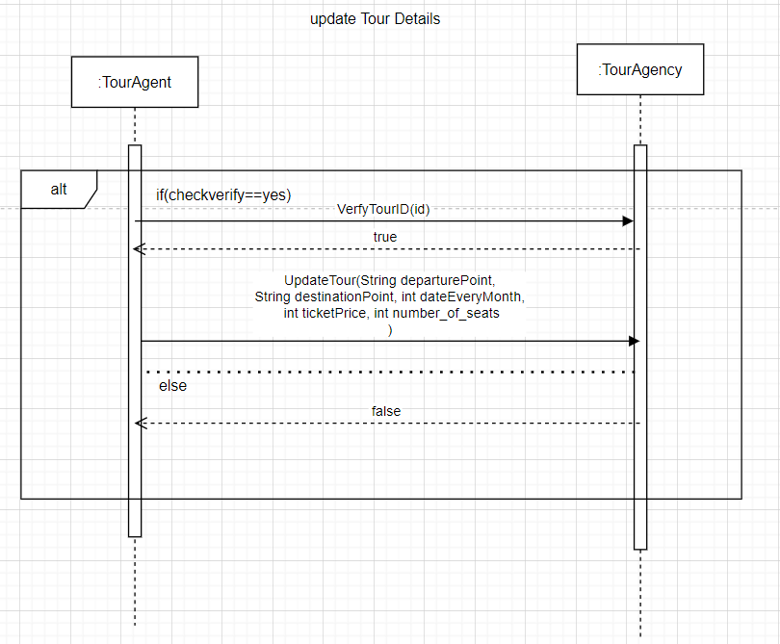

Figure update tour details System Sequence Diagram

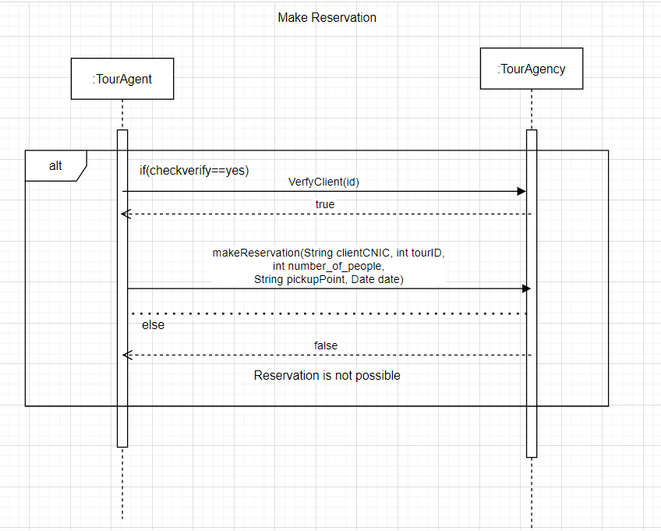

Figure Make reservation System Sequence Diagram

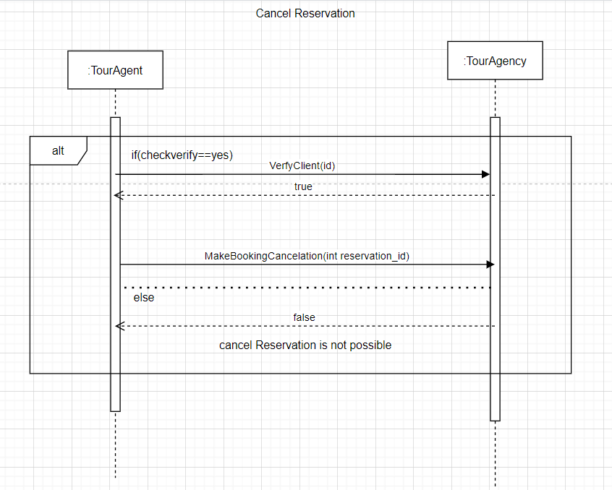

Figure Cancel reservation System Sequence Diagram

# Sequence Diagrams:

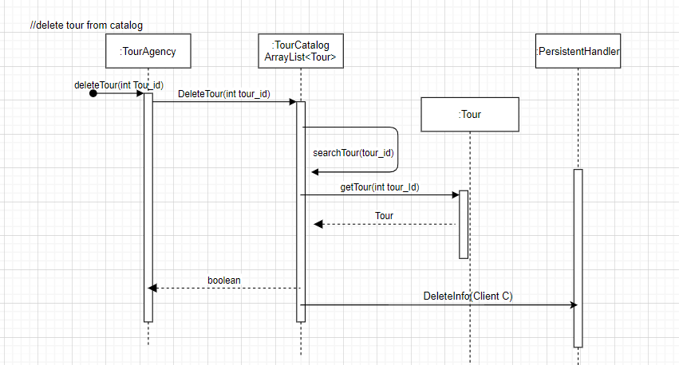

Figure Delete Tour Sequence Diagram

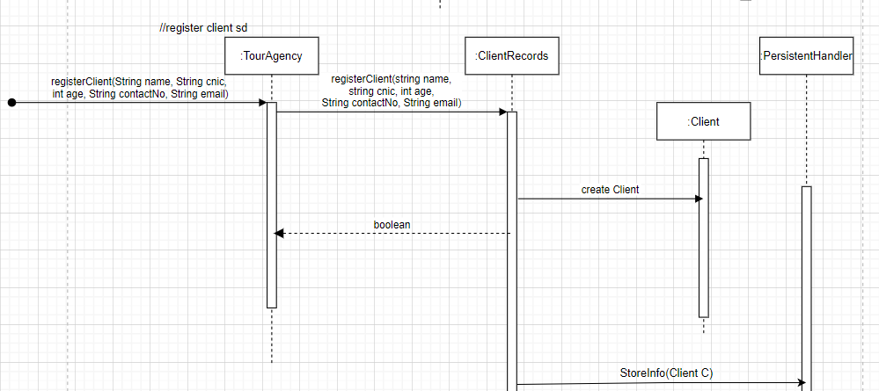

Figure Register Client Sequence Diagram

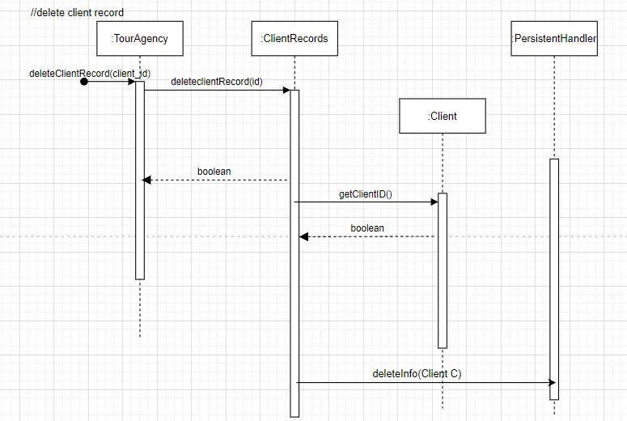

Figure Delete Client Sequence Diagram

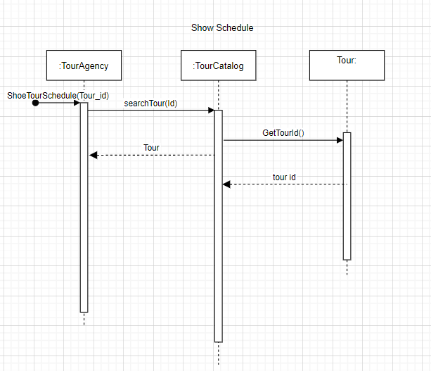

Figure Show Tour Schedule Sequence Diagram

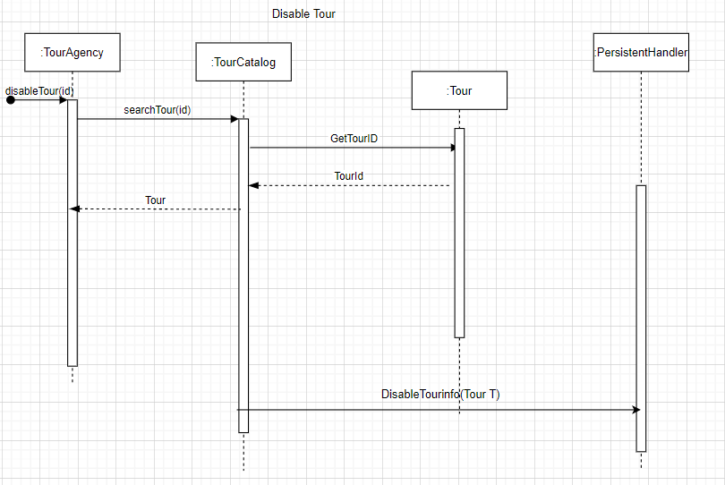

Figure Disable Tour Sequence Diagram

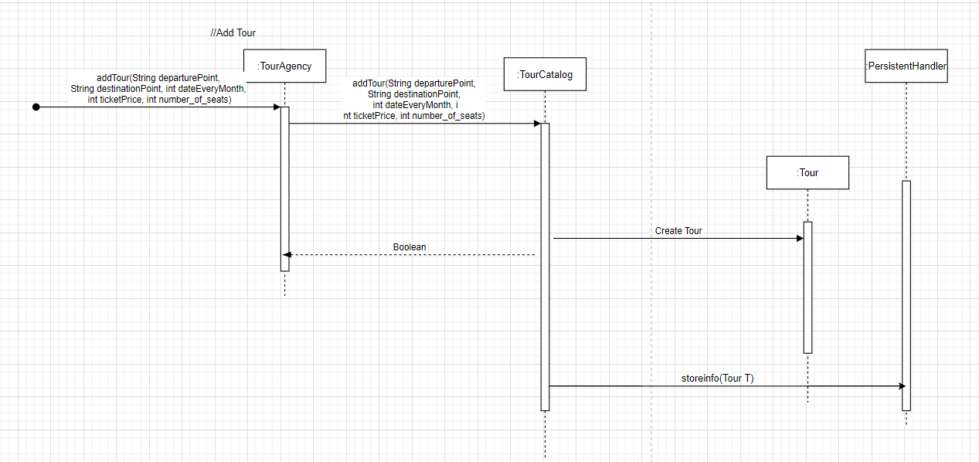

Figure Add Tour Sequence Diagram

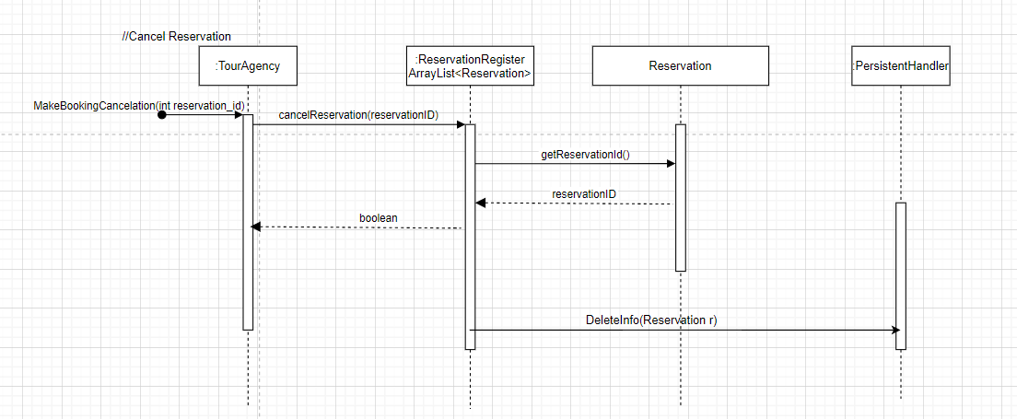

Figure Cancel Reservation Sequence Diagram

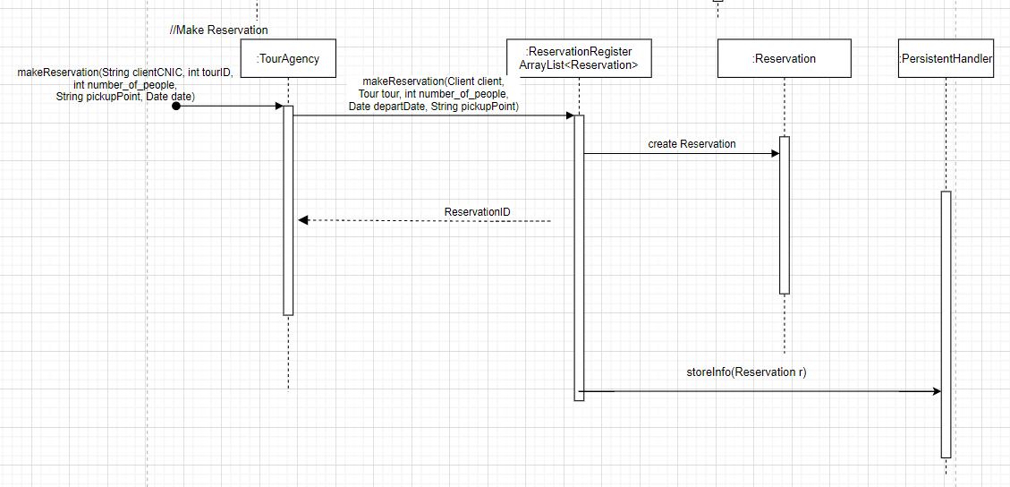

Figure Make Reservation Sequence Diagram

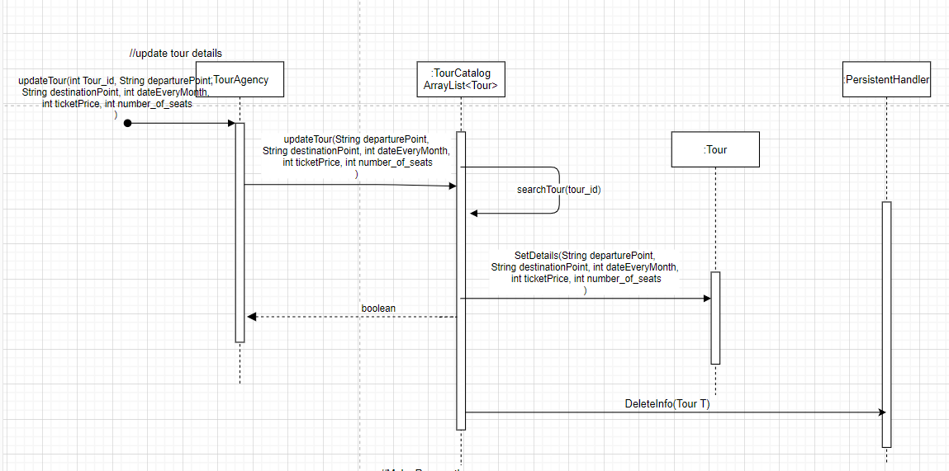

Figure Update Tour Details Sequence Diagram

# Class Diagram:

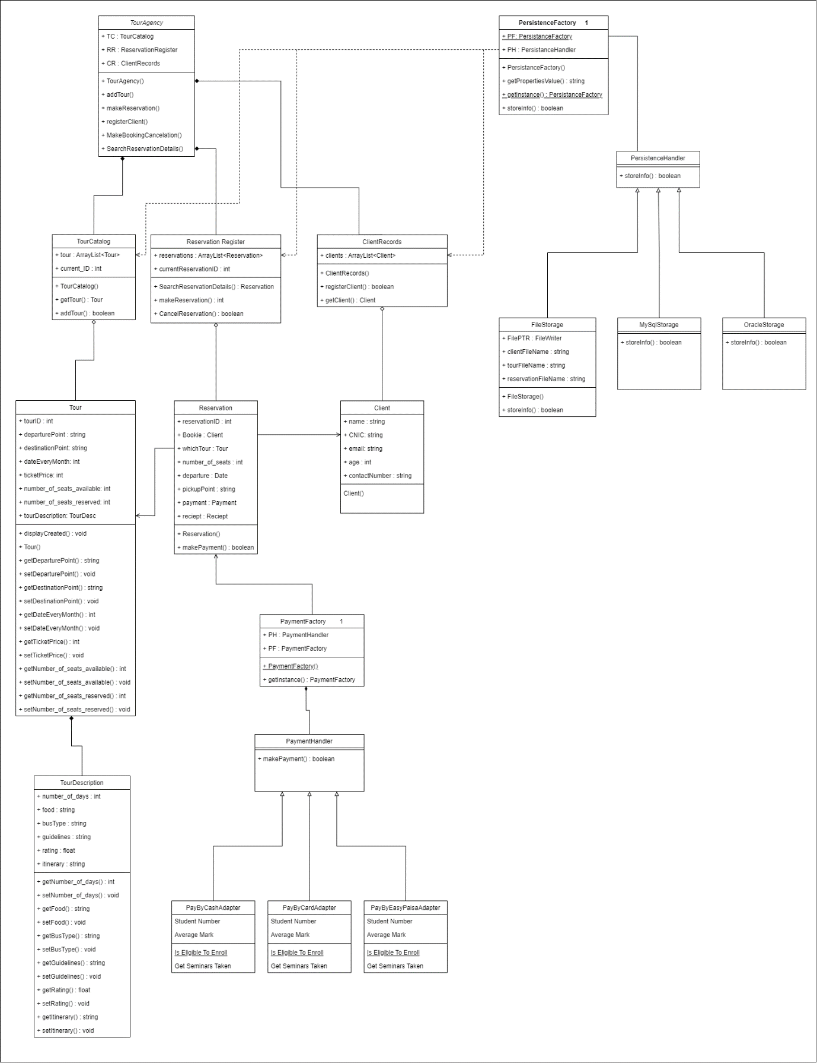

# UI screenshots:

Figure Main Menu

